**Data Structures and Algorithm**



Session: 2022 – 2026

**Submitted by:**

Mohammad Abdullah 2022-CS-155

**Submitted to:**

Sir. Muhammad Faraz

Department of Computer Science

**University of Engineering and Technology**

**Lahore, Pakistan**

* **Grow-able Array**

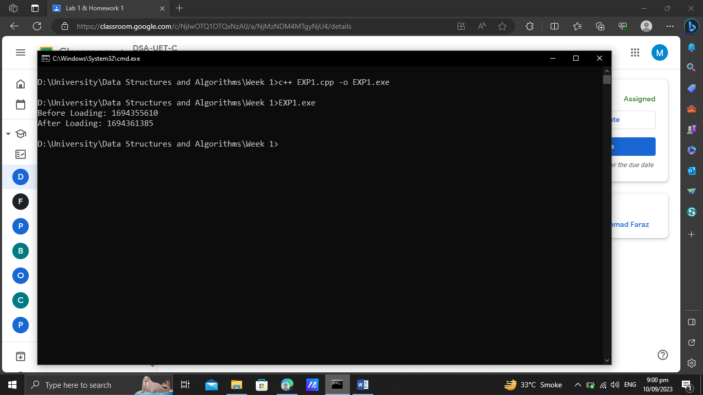

* **Vector**

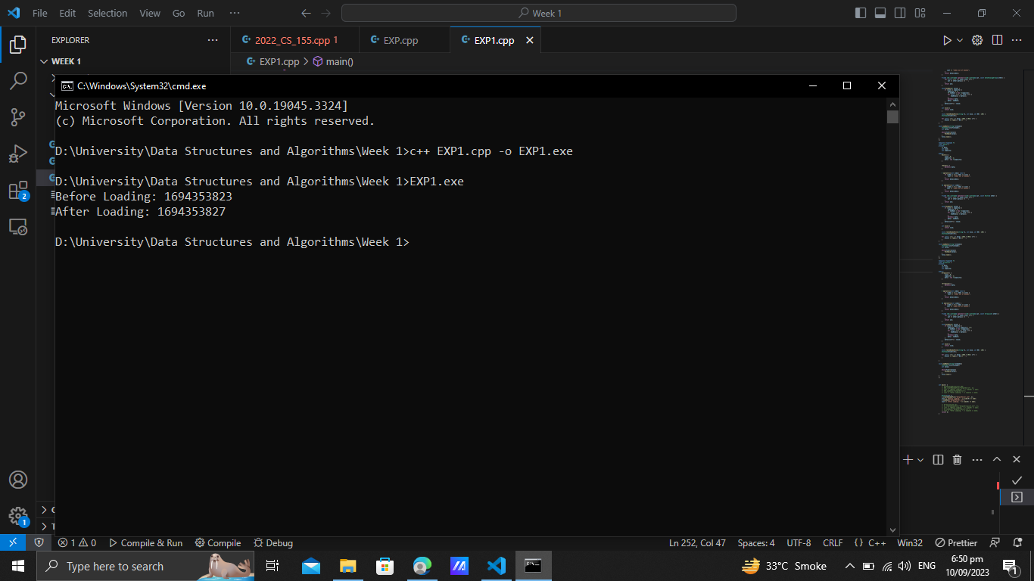

* **Array-List**

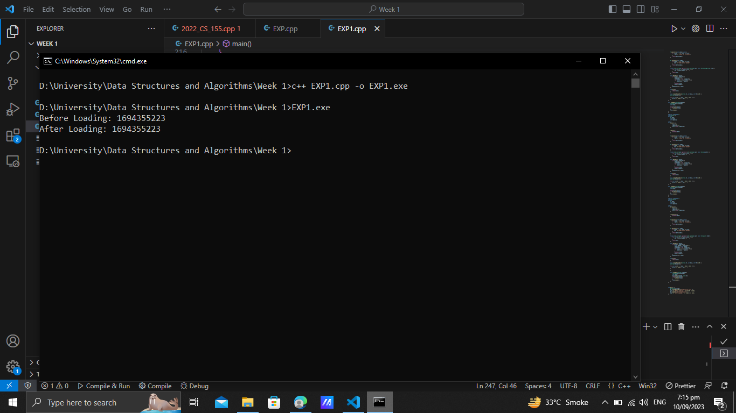

* **Summary**

As we can see that the time taken by array-list is the fastest. Its time before creating file and after reloading a file is the same. The difference between them is zero, so that is why it is the fastest. The difference for vector is 4. Its speed for loading is less than array-list. The difference for grow-able array is much greater, that is why it is the slowest among these three.